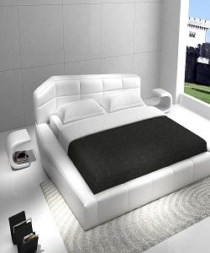

Luxury Universal Bed

$412.15

Availability: In stock

Description

Universal White Eco Leather King Size Platform Bed set 3Pcs nationwide furniture is proud to introduce our new line of beds. The exclusive design of platform bed is sure to give a timeless appeal. This bed is a beautiful piece of today’s modern furniture. This bed comes wrapped in a stunning white leather on the headboard, frame, and foot Board. The headboard has a stylish triangle look with a tufted design in the leather. Bold, European-inspired design. From rugs in wow- worthy prints with ultra-mod, glossy silhouettes design goes hand in hand with versatility and affordability. A mattress does NOT come included with the bed. Available in both King and Queen Size.